Section 8

Creating participant details

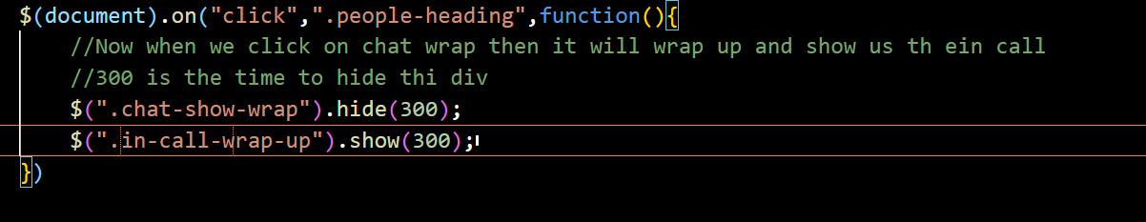

* But after doing the chat are will disappear for just a few seconds
* So we will do some chages in index.html

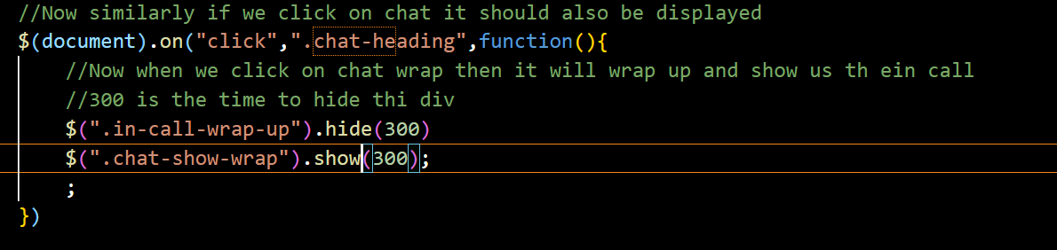

* 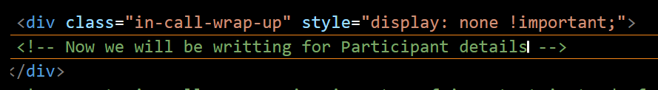
* Now after writing html tag now we will dynamically show the number of participants present in the class,
* 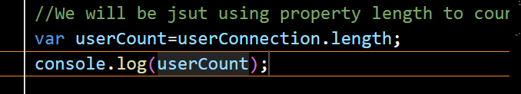

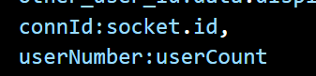

* Now go to app.js and find the event inform_other_about_me and just add the userNumber
* 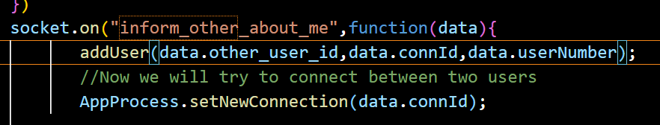
* 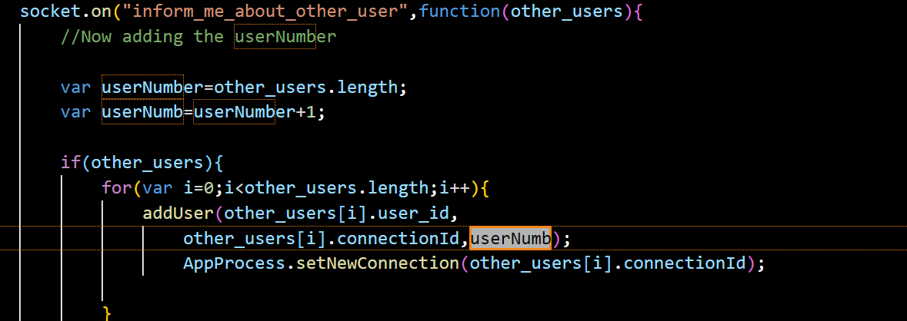
* Now in addUser function we will add the third parameter userNumb
* Now we will go to function addUser
* And then go to index.html and copy the in-call
* 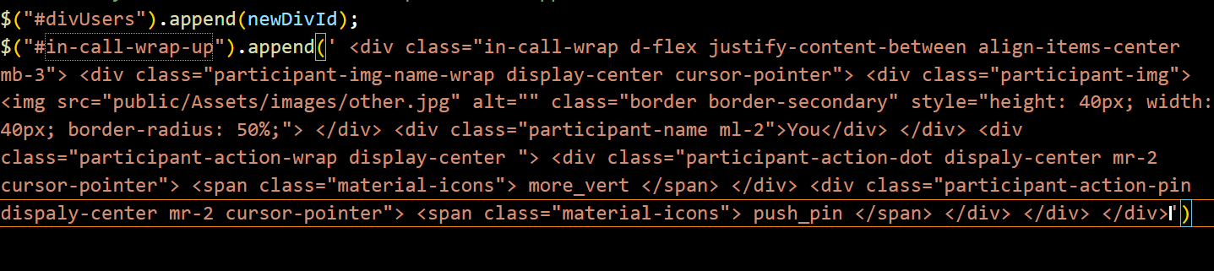
* After this edit the copied html tag
* 
* 

Part2:

* Now if some user gets disconnected then he should be remove from participants list
* 